
MODUL 14 PERKULIAHAN 2025
English for General Purposes
- 4 LANGUAGE SKILLS
- Grammar:
- VOCABULARY

Fakultas | Program Studi | TatapMuka | Kode MK | KELAS |   DisusunOleh  Drs. Budiantoro, MA
 | Program  AKUNTASI & MANAJEMEN | 14

Abstract Society 5.0 should be one that "will be able to balance economic advancement with the resolution of social problems by providing goods and services that granularly address manifold latent needs regardless of locale, age, sex, or language." The vision of Society 5.0 necessitates a reframe of two types of relationships: the relationship between technology and society and the relationship between individuals and society as mediated by technology. In this light, the first chapter provides an overview of the concept of Society 5.0. It elucidates the differences between today's society and Society 5.0. In this book, it proposes a strategy for approaching Society 5.0.

Competency
Students are able to understand, first, the vocabulary by listening, speaking, reading and writing from general resources of Presenting The topics below:
- How we approach society 5.0
- Merging cyberspace with phisical space
- Knowledge intensive society
- Data driven society
- Industry 4.0 and society 5.0

What Is Society 5.0?
- 1.1 How We Approach Society 5.0

The Schema of Society 5.0
The basic schema of Society 5.0 is that data are collected from the “real world” and processed by computers, with the results being applied in the real world. This schema is not new in itself. To cite a familiar example, air-conditioning units automatically keep a room at the temperature programmed into the unit. An air conditioner regularly measures the room’s temperature, and an internal microcomputer then compares the temperature reading with the registered temperature setting. Depending on the result, the airflow is activated or deactivated automatically, such that the room maintains the desired temperature. Many of the systems we rely on in society use this basic mechanism. It underlies the systems responsible for keeping our homes adequately supplied with electricity, and those that keep the trains running on time. This mechanism relies on computerized automated controls. When people use the term “information society,” they mean a society in which each of these systems collects data, processes them, and then applies the results in a particular real-world environment.
So what makes Society 5.0 different? Instead of having each system operating within a limited scope, such as keeping a room comfortable, supplying energy, or ensuring that the trains run on time, Society 5.0 will have systems that operate throughout society in an integrated fashion. To ensure happiness and comfort, it is not enough just to have comfortable room temperatures. We require comfort in all aspects of life, including in energy, transport, medical care, shopping, education, work, and leisure. To this end, systems must gather varied and voluminous real-world data. This data must then be processed by sophisticated IT systems such as AI, as only these IT systems could handle such a vast array of data. The information yielded from such processing must then be applied in the real world so as to make our lives happier and more comfortable. But does this not happen already? The difference is that in Society 5.0, the resulting information will not just guide the operation of an air conditioner, generator, or railway; it will directly shape our actions and behavior. In summary, Society 5.0 will feature an iterative cycle in which data are gathered, analyzed, and then converted into meaningful information, which is then applied in the real world; moreover, this cycle operates at a society-wide level.

Merging Cyberspace and Physical Space
Having clarified the basic schema, we now turn to the next question: what do we mean by “merging the physical space (real world) and cyberspace?” Cyberspace refers to a digital space in which real-world data are collected and analyzed to derive solutions. The term was coined to describe an imaginary or virtual area, where swathes of raw data are freely accessed and converted into useful information, which can then be shared with others. The infrastructure of this space is the vast array of computer networks.
However, in the case of Society 5.0, cyberspace does not just mean a space for exchanging vast volumes of data. It also means a space created by computer networks for analyzing problems and modeling practical, real-world solutions. When the computer systems of Society 5.0 analyze raw real-world data, they must do so using a structure that mirrors the real, physical world. As complicated as this may sound, the principle is very simple. To use the air conditioner example again, the internal microcomputer runs a program to measure a variable that describes the room temperature (let us call this variable “T”). The program compares the T value against the registered temperature setting and then determines whether to activate or stop the airflow. Thus, such an air conditioner has a discrete cyber model that analyzes the room with a single parameter, T. Let us call this the “room model.” Modern air-conditioning systems can also sense the positions of people in the room and customize the temperature accordingly. Such systems allow for a more complex cyber room model, one that uses a range of parameters—such as room size, temperatures of different parts of the room, and positions of the room’s inhabitants. The more closely one wants to meet people’s needs for happiness and comfort, the more granular (or closer to the real world) the cyber model must be (see Fig. 1.1). The ultimate objective of Society 5.0 is to incorporate real-world models into cyberspace such that they can deliver highly nuanced solutions to real-life problems.
Open image in new window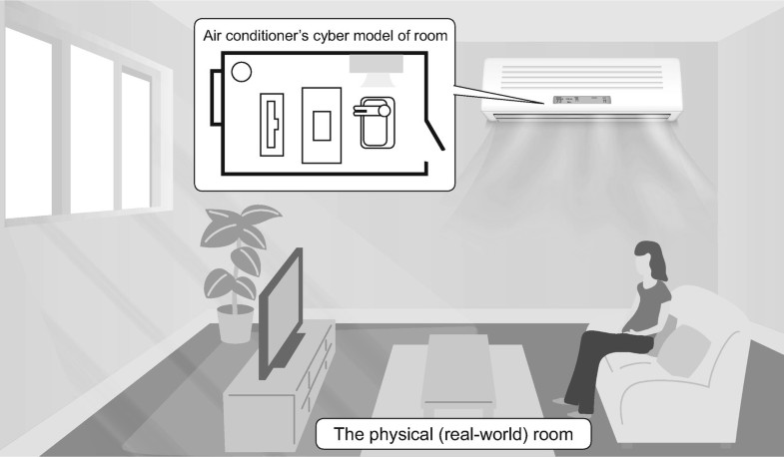
Fig. 1.1
Physical space (the room) and cyberspace (the air conditioner’s model of the room)
What, then, is physical space? Physical space refers to the real world, from which raw data are collected and into which solutions are applied. Some might interpret “real world” to mean everything that is real, including computer systems. Hence, the government literature adopted the descriptor “physical” to distinguish this space from cyberspace. This book uses the expression “physical space (real world).”
As the next section explains, the idea of merging cyberspace with the physical space (real world) refers to a cycle in which data smoothly flow from the physical space (real world) into cyberspace and then flow back from cyberspace into the physical space (real world) in the form of meaningful information. Hitherto, we have relied on systems such as energy supply and rail transport systems, each of which governs some part of the physical world and is controlled separately. However, once all of these systems are interconnected through cyberspace, they will enable much more sophisticated services and produce much greater value in the real world.

Toward a People-Centric Society
It is through the mechanism described above that Society 5.0 will become a people-centric society. Originally, the purpose of an air conditioner was to keep a room at the desired temperature. The matter is simple enough if temperature control is our sole objective, but things start to get more complicated once our goal is a people-centric society. The government’s 2017 comprehensive strategy describes a human-centered society as one that can “balance economic advancement with the resolution of social problems … to ensure that all citizens can lead high-quality lives full of comfort and vitality.” The authors of the strategy described it as such because they understood how difficult it can be to balance economic development, resolution of social problems, and quality of life. Society 5.0 was thus proposed as a way to attempt this feat.
Air conditioners play an invaluable role in society; many offices and factories would struggle to function if their premises were not comfortably air-conditioned. Yet air conditioners also contribute to global warming: they often run on power derived from burning fossil fuels, which releases greenhouse gases. Thus, we cannot only consider the need to keep buildings comfortably air-conditioned; we must also consider the effects upon society as a whole, or indeed upon our entire ecosystem. As this example illustrates, balancing these two interests is no easy task. If we single-mindedly pursue economic growth, we may end up becoming a society of mass production and mass consumption, and harm the planet in the process. However, if we forgo our pleasures and restrict our energy consumption to the bare minimum, life becomes drab and uncomfortable. Moreover, if we all lived such a spartan existence, the economy would stall. Society 5.0 is an attempt to overcome this seemingly intractable dilemma. In this book, we outline the approach to this dilemma, an approach that we have termed “Habitat Innovation.” We also examine the direction of the technological developments underlying Habitat Innovation.
The task of solving social problems without sacrificing quality of life is difficult for another reason: it requires us to balance what is best for society with what is best for the individual. Suppose you live alone in a single-room apartment. Who decides on your air conditioner’s temperature settings? Clearly, you are free to decide this for yourself. Suppose, however, that you are just one of the inhabitants. Each person may have their own temperature preferences. How do you ensure that you are all happy and comfortable? Should you take a poll of each person’s preferred temperature and then calculate the mean? Should you hold a debate about the ideal temperature and then take a vote? Should someone in your group make a final decision? Not so simple anymore, is it? Yet this kind of scenario is at the easy end of the spectrum. Just imagine applying this to more complex social scenarios, in which you must consider the happiness of countless individuals, and do so using a dizzying array of scales and metrics. Could you reconcile or find an acceptable balance between the interests of the society and that of the individuals in it? This challenge is linked at a fundamental level to the question of what we mean by “high-quality lives full of comfort and vitality.” There are many different definitions and measures of well-being. Well-being is not like the temperature of a room; you cannot quantify it in most cases. It will take us much more time until we can derive clear-cut solutions to this problem, but for the time being, humanities and social science researchers are delving into the peripheries of matter and considering how best we can approach the core.
The vision of society that Society 5.0 describes requires us to think about two kinds of relationships: the relationship between technology and society and the technology-mediated relationship between individuals and society.
- 1.2 Merging Cyberspace with Physical Space
In the previous section, we learned that the underlying mechanism of Society 5.0 is the merging of cyberspace with the physical space (real world). This section further clarifies what such a convergence means and how it can benefit society.

Modeling Real-World Issues
Cyberspace is the electronic world inside computers. Data from the physical space (real world) are analyzed in cyberspace so as to derive solutions for managing or improving society. Once these solutions are implemented in physical space (real world), the outcomes are evaluated, which generates data. This data is then input back into cyberspace for analysis and, if there are any problems, further solutions will be derived. This cycle, whereby society is continuously adjusted and improved, is what Society 5.0 is all about.
To derive solutions for the physical space (real world), cyberspace must have a structure mirroring that of the real world. Consider once again the example of the air conditioner (see Fig. 1.2). In this case, the cyber model must have a real-world mirroring structure necessary for air-conditioning the room. In other words, the system must model the physical characteristics of the room to understand how the room will change if the airflow is increased or decreased. If the system models the room’s features as they are in reality, it can run cyber simulations and learn strategies for keeping the room optimally air-conditioned.
Open image in new window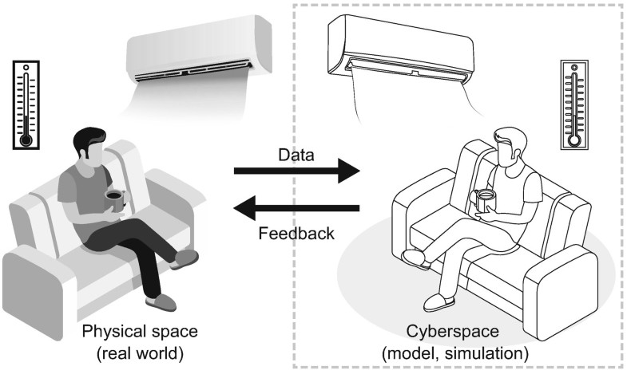
Fig. 1.2
Modeling the real world
The impact of a given level of airflow upon the room temperature will depend on various factors, including the room’s size, the heat-insulating properties of the walls, the number of inhabitants, and the exterior temperature. It is no easy task to acquire a model that accurately reflects the room’s real-life conditions. This is where the Internet of Things (IoT) and artificial intelligence (AI) come in. IoT allows varied and voluminous data (in this case, the room’s size, the temperatures in different parts of the room, the room’s inhabitants and their spatial distribution, etc.) to be gathered in cyberspace. AI, on the other hand, can analyze the vast amounts of data obtained and then create a cyber model of the room that behaves just like the real thing.
Once this cyber model is established, the system can estimate how best to condition the room and then implement this strategy in the physical space (real world). The system can measure how the airflow is affecting the room temperature and incorporate this information back into cyberspace. If the room’s actual temperature differs from the target temperature, then the cyber model of the room must have missed the mark. The AI notes the mistake and readjusts the model accordingly. Through this calibration cycle, the cyber model of the room will eventually come to adequately resemble the actual room. Thus, when the literature mentions the “merging” of cyberspace and physical space, it means that these two spaces have come to resemble one another so much as to be indistinguishable.
The idea of merging the cyber and the physical is not novel. Power generation and rail transport, for example, now use control systems that model their target environment so as to supply the right level of energy or run the trains on time. Such systems are known as cyber-physical systems (CPS). However, the convergence of the cyber and physical that Society 5.0 envisages does not involve separate, isolated systems. Society 5.0 is about cyber-physical convergence at the level of society as a whole. Convergence at this macro-level could perhaps be described as the merging of spaces with spaces.

Understanding How Services Are Interconnected
When the convergence comes to fruition, models that had until then been generated separately in each system will become interconnected in cyberspace. Consequently, we will come to see how different services interconnect. How will this insight benefit society?
We rely on many types of services, including those related to energy, transport, water, healthcare, public security, distribution, retail, education, and entertainment. It may appear that each service is separate, but they are in fact interconnected. To build a better society, we must learn to see how services interconnect and devise solutions accordingly.
Take urban traffic congestion as an example. One way of solving this problem might be to develop a subway system, but this costs time and money. Before rushing to take action, you should consider why the congestion occurs in the first place. In some cities, people prefer to travel by car because of poor public security. In other cities, the cause of congestion may be an inadequate water infrastructure, which causes roads to be inundated once it rains. In some cities, there is a rich riverine infrastructure, yet the inhabitants avoid the river bus owing to water pollution, a result of rapid urbanization. In other cases, congestion is the result of rampant illegal parking, which itself was caused by a failure to build adequate parking facilities close to marketplaces. As these examples illustrate, transport is interconnected with other services. Thus, although a subway system might be an effective solution to congestion, if the interconnections with other services are considered, a cheaper and quicker alternative, such as enhancing public security, installing better water infrastructure, improving sewage purification, or relocating marketplaces, may be discovered.
If an entire city is modeled in cyberspace, it will be possible to thoroughly analyze the root causes of the issue, which in this case is traffic congestion. It will also facilitate the process of devising solutions; simulations could be run in cyberspace to identify how best to allocate limited budgets so as to eliminate the congestion. The secondary effects of each potential solution could also be identified so as to avoid unintended consequences.
Urban planners already examine the relationship between different services. The difference is that the convergence of cyberspace and physical space (real world) will yield vast resources of data gathered from the physical space (real world). This data will help urban planners understand more accurately the interactions between different services. In other words, AI can spot connections that a human would overlook. With such AI, we will learn how different services in a given area interact in the short term, and how a given service would shape other services over a longer time span. Additionally, AI-derived insights into interservice dynamics may yield new services. In the years ahead, all these possibilities will garner more serious attention than they have received so far.
Thus, by coupling and linking in cyberspace services, which have been so far administered and managed separately, it will be possible to integrate services, and thus derive new value in the physical space (real world). This is the value we can expect to gain from connecting services via cyberspace.

Accumulating and Sharing Knowledge
Services are not the only things that can be linked in cyberspace. Cities can be linked with other cities, and societies with other societies. By modeling a city or society in cyberspace and linking it with other cities or societies, it will be possible to extrapolate existing knowledge.
Let us consider an example. Imagine that you have analyzed some data pertaining to a given city using a certain method. This method may be applicable to another city. As the two cities have different environments, the results of your analysis in the second city may have limited use in their raw form, but the analytical method itself is applicable to both cities. Now let us say that you implement a strategy in one city and record the outcome. Whether the strategy proves a success or a failure, the lessons could be applied to other cities in many cases. Likewise, case data on solutions to problems in Japan may be applicable to emerging nations, thereby crossing physical and temporal barriers.
As mentioned previously, “cyberspace” originally meant an imaginary or virtual space wherein vast sums of raw data are freely and broadly accessed and converted into meaningful information, which then gets shared among or viewed by different users. As also mentioned previously, the infrastructure upon which cyberspace exists is the vast array of computer networks. These computer networks enable information and knowledge to be shared without the restrictions of time and space. This accumulation and sharing of knowledge is the original purpose of cyberspace (see Fig. 1.3).
Open image in new window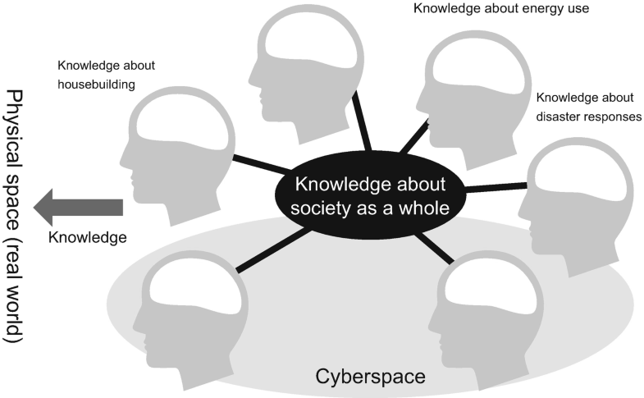
Fig. 1.3
Accumulating and sharing knowledge
There are many ways in which cyberspace could facilitate the accumulation and sharing of knowledge, in addition to modeling and analyzing phenomena in physical space (real world). For example, if a municipality succeeds in becoming a supersmart society, the knowledge behind this success can be applied the very next day in another municipality situated far away. Then, some decades later, the knowledge can be used overseas, in a country that is less economically developed.
In this section, we discussed what the “merging of cyberspace and physical space (real world)” means in the context of Society 5.0. We also discussed how cyberspace can help us link together real-world phenomena so as to create new value. The “merging” refers to the process of gathering raw data from the physical space (real world), using the data to derive models in cyberspace, and iteratively improving these models. This process creates value in that the models generate new knowledge, which can then be accumulated and shared. It differs from the existing process in that a much broader array of data is gathered, and gathered at a much greater volume and a much higher frequency by comparison. Another difference is that AI and other modern innovations can process the vast ocean of data to derive new knowledge.
Insofar as we focus on the knowledge-production aspect, we might aptly call Society 5.0 a knowledge-intensive society. If we focus more on the data-production aspect, we might want to call it a data-driven society. So far, we have not clearly defined the terms “data,” “information,” and “knowledge.” The following section, however, clarifies our usage of each of these terms and then discusses what we mean by a knowledge-intensive society and a data-driven society.
- 1.3 Knowledge-Intensive Society
Society 5.0 identifies three elements that drive social innovation: data, information, and knowledge. In this section, we clarify what these three terms mean and describe the ways in which Society 5.0 constitutes a knowledge-intensive society (see Fig. 1.4).
Open image in new window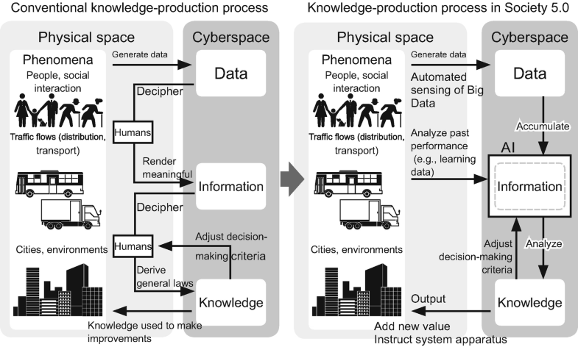
Fig. 1.4
Data, information, and knowledge

Data, Information, and Knowledge
First, what are data? Generally, data refer to tangible and intangible phenomena in the physical space (real world) that are represented as numerical values, states, names, or binary figures (0 or 1) telling us whether a thing is present or absent. To illustrate this definition, we will refer to the population of a hypothetical municipality (let us call it Town A). In Japan, the town’s population could be worked out by referring to the relevant entries in the national registry of citizens (the “Basic Resident Register”). From this source, the attributes of Town A’s residents, including their gender, household composition, and address, could be found. These facts represent Town A’s data. Data are the most basic of the three elements (data, information, and knowledge) that are accumulated in cyberspace.
If this is data, what is information? Information is data that has been rendered meaningful by selecting and processing it for a particular purpose or as part of a course of action. To return to Town A, once you have the raw population data, it could be broken down by age group to see the demographic trends over the past 10 years or the rate of aging. The age breakdown could also be used to plot a graph showing the population pyramid. The results of such analysis represent Town A’s information. By analyzing the demographic trends, you could determine whether Town A is on a growth trajectory (its population is growing) or whether it is on the decline (its population is shrinking). It is the addition of such meaningful indications that turns data into information.
Suppose the information tells you that Town A’s population is shrinking. To address this problem, you must analyze the causes of the population decline. Perhaps the decline is driven by falling birthrates and population aging. Or perhaps there is a net outflow (the people moving away from the town outnumber the people coming in). The decision of what to do could be worked out by comparing Town A’s population trends with that of other municipalities and referring to best practice models developed by experts. Knowledge, then, is what enables you to make a decision. Information becomes knowledge when it is comprehended, analyzed, and related to general laws, including best practices and precedents. Knowledge can also be described as generalized observations extracted from individual cases. Knowledge allows you to surmise the causes of a problem, and it also helps you to derive solutions to address these causal factors. The more knowledge you have, the more equipped you are to derive a judicious information-based decision.

What Is a Knowledge-Intensive Society?
Data becomes useful to us once we convert it to information, and then into knowledge. Hitherto, this conversion process has been driven by human–computer interactions. In Society 5.0, the process will be driven without human intervention; of the three elements, humans will only gain greater opportunities to access AI-derived knowledge, the final output of the conversion process.
How will this change affect society?
Like other developed nations, Japan evolved from a labor-intensive society, in which production relied on the efforts of a massive workforce, into a capital-intensive society, which was focused on tangible goods and was based on mass production and mass consumption (both of which resulted from industrial revolutions). In the capital-intensive society, cities developed around seaports and airports where tangible goods were clustered. Under the Society 5.0 way of thinking, however, value is generated not from clusters of tangible assets but rather from knowledge spaces—spaces where data and information are gathered and then deciphered and deployed through knowledge (Gonokami 2017). In this sense, a knowledge-intensive society is a key aspect of Society 5.0.
New knowledge will arise when data and information are deployed inter-connectedly. New knowledge can spark innovation in tertiary industries such as services, but it will also do so in the more traditional primary and secondary industries such as agriculture and manufacturing. Japan’s agricultural sector is somewhat inefficient owing to sporadically distributed farmland. A knowledge-intensive Japan, however, could spark an agricultural renaissance by leveraging detailed spatial information and predictive weather knowledge along with drone and robotic technologies. A knowledge-intensive society may also generate new industries and transform the industrial structure.
In pursuing this paradigm shift, universities and businesses, which have until now played a core role in technological development, will need to play a new kind of role. The role of technology thus far has been to add value to tangible goods, but in the knowledge-intensive society, universities and businesses will need to help cultivate new industries, which in turn will generate new value by clustering and combining knowledge.

Rules and Norms in the Knowledge-Intensive Society
In the coming knowledge-intensive society, technology will play a critical role in building information integration architecture—architecture that enables data to be collected, synthesized, and then integrated with information in heterogeneous fields. At the same time, however, we must establish rules and norms governing how we approach data. Data producers must uphold certain rules and standards of conduct, and those who analyze or use the data must be sufficiently data literate.
Let us consider the situation for data producers. Technology facilitates the knowledge-generation process, but no matter how advanced this process becomes, if the data is unsuitable for analysis, you will fail to derive accurate knowledge. Although automated processes can catch some data errors, it is difficult at present to catch every error owing to the lack of a coordinated system. In other words, every data producer follows its own separate method of data production. To illustrate this point, we will use a familiar example: tourism. Until 2009, when the Japan Tourism Agency issued the Common Standards for Estimating Tourist Arrivals (Japan Tourism Agency 2019), each municipality followed its own method to survey and compile tourist data. This practice prevented the data from being useful; although tourist trends could be analyzed in each municipality, the trends between municipalities could not be compared. Another issue was that despite the incomparability of the data, third parties might attempt comparisons anyway, which would result in erroneous knowledge. If anyone can tally the number of visitors with a simple device and then publish the data online, it is all the more important to establish common standards and procedures, so that data producers approach the data judiciously, understanding how it will be used.

Information Literacy
What about the people who analyze and use the data? One of the top tasks in relation to Society 5.0 is to ensure that such individuals are literate in personal data and information. Let us consider an example. As part of the European Union’s Horizon 2020 program (European Commission 2019), Barcelona organized the “smart citizen” project, in which citizens developed a sensor board that can be installed in balconies to monitor air and noise pollution. The data recorded by the sensors is published as open-source data (Smart Citizens 2019), and citizens can cite this open-source data in their campaigns for better environmental policies. In this project, Barcelonans are the data producers, and insofar as they derive meaningful information from the data, they are data users as well. By contrast, Japanese people typically regard data use as the sole preserve of public servants and businesses, and few see data as something that they themselves could use, as Barcelona’s “smart citizens” do. What matters is to promote public discussion and action regarding the society-wide use of data.
The benefits of Society 5.0 should be enjoyed by all. As the Japanese government literature says, Society 5.0 should be one that, “through the high degree of merging between cyberspace and physical space, will be able to balance economic advancement with the resolution of social problems by providing goods and services that granularly address manifold latent needs regardless of locale, age, sex, or language.” But can you have too much of a good thing? If every service and business is highly data driven, might this not encourage people to lose their agency in society and passively follow AI-generated recommendations on which goods to purchase or which services to use? That does not sound like a very interesting life. If the goods and services of society are to be available to all, we must ensure that people still lead purpose-driven and creative lives. To this end, universities and businesses will have an increasingly crucial role to play. As we move toward a truly people-centric life, progress in information technology must be accompanied by efforts to train up industrial innovators and raise the information literacy of each and every citizen. Universities, for their part, in addition to spurring technological progress as before, must additionally be responsible for cultivating literacy among information users through both general curricula and recurrent education, so as to promote the civil society that embodies Society 5.0.
- 1.4 Data-Driven Society
Society 5.0 is described as a data-driven society. What is a data-driven society? We live in a so-called information society, so how does this differ from a data-driven society? The previous section defined information as data that has been processed and rendered meaningful, while it defined knowledge as the general empirical laws extracted from such information. Compared to information and knowledge, data exist at a more basic level. What, then, does it mean for a society to be driven by this most primitive of the three elements? The data-driven society is crucial for understanding Society 5.0, a point that is aptly illustrated by the fact that both terms appear in the Japanese Government’s “Growth Strategy 2018” (Growth Strategy Council 2018). Accordingly, this section explores the question in some detail.

What Is a Data-Driven Society?
First, let us see how the data-driven society is defined in the government literature. The term featured in the literature even before Society 5.0 was proposed. For example, it appeared in a 2015 report of the Ministry of Economy, Trade and Industry’s (METI) Industrial Structure Council (Ministry of Economy 2015). This report defines a data-driven society as a society “where the above-mentioned CPS is applied to various industrial societies through digitization and networking of things using IoT, and the digitized data is converted into intelligence and applied to the real world, and then the data acquire added value and move the real world [sic].” In this quotation, “intelligence” equates with the information and knowledge discussed in the previous section.
More simply, the data-driven society is a society where data (gathered by IoT networks) are converted into information and knowledge, which then “drive” (or as the literature says, “move”) the real world. As accurate as this definition may be, it may still leave readers nonplussed. The previous section described the relationships between data, information, and knowledge, but this does not give us a clear picture of how data drives the real world. So how exactly does data drive the real world? It drives the world in two different ways. First, data drives the world indirectly via humans. That is, vast resources of data inform and guide human decision-making, which then effects change in the world. Second, data drive the world directly (without the mediation of humans) through automated processes. Let us consider examples of both.
Regarding the former, suppose you are designing an urban transport system; under a conventional approach, you would consult data and then make decisions based on this data. You would rely on numerous researchers to gather traffic volume data using manually operated head counters, and these findings would inform your designs for road traffic, bus services, metro system, and the like. However, because these traffic data are costly to gather, only a limited amount are available (there are only data for a limited number of sites in the city and these are dated several years apart).
In the data-driven society, however, the data available would be staggering in volume and breadth, and be real-time data to boot. Technology allows you to monitor the traffic flows across the city as a whole in real time. For example, to monitor people flows, you could refer to smartphone data or access the data of prepaid transport cards (known as IC cards in Japan). To monitor foot and vehicle traffic volume, you could analyze the footage of CCTV cameras installed along roads and in buildings. You could also collate this data with shopping data to gain insights into the motives for people’s movements. By visually modeling all this urban data in real time, you will grasp the entire workings and dynamics of the city.
Before enacting any changes in the city, you must hold a consultation process in which numerous stakeholders share their understanding of the status quo and how it should be changed, if at all. A visual model of the city grounded in voluminous, varied, and real-time data would radically shape this consultation and decision-making processes. This is what it means for data to drive society indirectly, via humans.
Now for the latter meaning—a society that is driven directly by automated systems. One example of automated control systems is traffic signals. Traffic lights shift between red, amber, and green, thanks to the operation of an internal computer program, one that humans designed.
However, if we want the kind of people-centric society that Society 5.0 describes, we must consider numerous variables and needs, even if we limit our focus to a traffic control system. Drivers may want minimal congestion, residents may want minimal traffic flows so as to limit exhaust fumes, and pedestrians might wish to have minimal waiting times at crosswalks. Railway level crossings can be a source of traffic congestion, so rail timetables would also have to be considered. All in all, a traffic control system is a very complex matter.
It is all but impossible for humans to design a program that can control traffic signals absolutely optimally, taking into account all the above variables and needs. Hence, we must look to AI. Humans can define an optimal traffic state and then let AI coordinate traffic signals accordingly. If we regularly input data, such as traffic volumes, exhaust volumes, and pedestrian waiting times, AI will start to learn the outcomes it can expect from a given traffic control pattern. In this way, AI will progressively derive general laws on how best to control traffic. Over time, the AI will learn how transport is affected by factors such as public events and weather conditions and come to understand the optimum responses to such phenomena.
Thus, in the future, AI will convert data into knowledge (general empirical laws) through an automated process, and then use this knowledge to automatically control traffic. Instead of traffic signals being controlled by a human-made computer program, they will be controlled by AI-generated optimum algorithms. This process is mediated by data, but not by humans: that is the second meaning of a data-driven society.

From the Information Society to the Data-Driven Society
So far, we have learned that the data-driven society is a society where IoT-gathered data is converted into information and knowledge, which then drives the real world either indirectly (with the mediation of humans) or directly (through automation). How does this differ from an information society? An information society derives value from information. A data-driven society (in both senses) derives value from data. The government’s Growth Strategy 2018 (Growth Strategy Council 2018) describes this idea in stark terms:
“…in the data-driven society of the 21st century, the most important currency of economic activity is high quality, up-to-date and abundant ‘real data’. Data has become so valuable that saying that the success or failure of a business depends on its access to data [is] by no means an exaggeration.”
Some might argue that we should shorten the term “data-driven society” to “data society,” so as to more easily compare and contrast it with the “information society.” However, the government decided to add “-driven” to underscore how future technological progress will result in extensive automation (nonhuman-mediated processes).
In this section, we learned about the two ways in which society will be data driven. Of the two, an automated society may seem the more futuristic. However, it would be a mistake to think of a human-mediated society as a transitionary state between today’s society and the ultimate state of full automation. Instead, human mediation and automation will exist side by side. In the case of traffic signals, AI is responsible for effectuating an optimal state, but it is humans who decide what this state is in the first place. Human-mediated processes, such as consultations in which the participants refer to visual urban data, will play an ever-greater role in building the people-centric society. We are the ones who decide how to strike a balance between different comfort needs, such as between drivers’ desire to travel smoothly without needing to constantly stop at red lights and pedestrians’ desire to cross the road quickly. Likewise, it is humans who define the criteria for measuring comfort and happiness. Standards of happiness vary between cultures and time periods. To find the right balance, consultation processes should involve as many stakeholders as possible, not least of whom should be residents—the chief actors of a local community. Once full consultations have been made and a consensus reached, this consensus can then be put into effect by automated technology. These parallel aspects of a data-driven society, by operating in tandem in this way, will support the people-centric Society 5.0 and provide the flexibility necessary to ensure that the underlying architecture is applicable in many different countries and cultures. Thus, solutions generated in Society 5.0 can contribute to other social problems in different parts of the world.
- 1.5 Industrie 4.0 and Society 5.0
In November 2011, the German Federal Government released “High-Tech Strategy 2020 Action Plan for Germany” (Industrie 4.0 Working Group 2013), which outlined a high-tech strategic initiative called Industrie (Industry) 4.0. This vision predated Society 5.0, as proposed in the 2016 Science and Technology Basic Plan, by 5 years. Why did Germany pursue a national campaign to promote science and technology in its manufacturing sector? This section outlines the new industrial vision that Industrie 4.0 encapsulated. It also compares Industrie 4.0 with Society 5.0 as a means of further clarifying the latter.

What Was Industrie 4.0?
Industrie 4.0 was a national strategic initiative led by the Ministry of Education and Research (BMBF) and the Ministry for Economic Affairs and Energy (BMWI). To deliberate on the initiative, a working group was formed consisting of actors from government as well as from businesses and universities. The working group was led by Henning Kagermann, former chairman of SAP SE and president of the German Academy of Science and Engineering (acatech). In April 2013, the working group issued its recommendations in a report titled “Recommendations for implementing the strategic initiative INDUSTRIE 4.0” (Industrie 4.0 Working Group 2013).
The report focused on deploying IoT in manufacturing so as to enable cyber-physical (CPS) systems that can add value to production activities. It also focused on promoting “smart factories,” which are factories that achieve significant savings in manufacturing costs.
According to the report, smart factories should use IoT devices and the Internet to gather data on all stages of the production process in the physical space (real world), and then recreate this data in cyberspace. AI then analyzes this cyber data, or runs simulations to derive optimal solutions. AI’s findings will be automatically fed back into real-world factory control systems. Simply put, smart factories are factories that think for themselves.
Smart factories enable automation and optimization across all aspects of manufacturing. As well as managing general production processes, they could handle payments for parts; they could even detect any abnormalities or deficiencies in the production apparatus and then automatically fix the problem or recalibrate a process. The chief actors in smart factories are sensors and AI.
As a proper noun, Industrie 4.0 denotes a uniquely German initiative, but the underlying concept––to deploy IoT in manufacturing––has gained global traction. This concept is more generally described as the “fourth industrial revolution,” and it describes an extensive trend to overturn industrial production.
But why four? To understand this, we need to recap the history of industrialization (see Fig. 1.5).
Open image in new window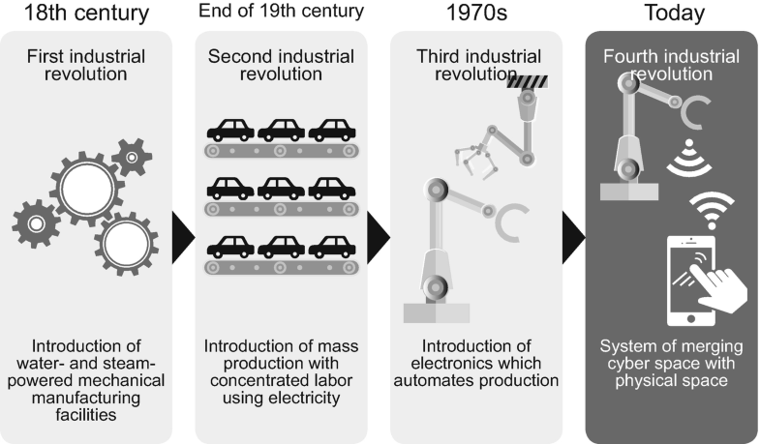
Fig. 1.5
The chronology of the industrial revolutions and the position of the fourth industrial revolution
The first industrial revolution began in Britain in the eighteenth century, and it was driven by the mechanization of manufacturing equipment. Water- and steam-powered machinery enabled a leap in productivity in the textile industry and other industries. The second industrial revolution began around the turn of the twentieth century, and involved mass production based on the division of labor. Producers shifted to fossil fuel-generated electric power, and factories became much larger. This second industrial revolution was epitomized by the Ford Motor Company’s auto production. The third industrial revolution, which began during the 1970s, involved electronics. Producers used robotic technology to automate some manufacturing processes, and consequently achieved significant leaps in productivity. It was during this time that Japanese manufacturing gained worldwide prominence.
Industrie 4.0 heralds the next stage of industrialization. As many readers will know, Japanese manufacturers already use robotics and sensor technology, and many processes are automated. Many of these readers may feel that the Japanese manufacturing has already made great strides in terms of productivity. Yet Industrie 4.0 is not just about making factories more efficient. As Taro Yamada argues, Industrie 4.0 is all about creating a data–information–knowledge cycle, in which all manner of manufacturing-related data, including data related to designs, clients, and suppliers, are gathered and shared among different fields and organizations (Yamada 2016).
The key difference between the third and fourth industrial revolution is that the latter uses data in a manner that surpasses traditional manufacturing frameworks. In the past, data related to the use of products, for example, would be abandoned upon the sale of the products; in the fourth stage of industrialization, however, manufacturers continue to gather this data after the products are sold. This practice allows manufacturers to identify latent needs from clients’ Big Data and strengthen their value networks, thereby creating new business opportunities. Another difference with Industrie 4.0 is that added value is created through mass customization. In other words, AI drives customized output, flexibly accommodating diverse demand.
Although Industrie 4.0 focused primarily on manufacturing, the scope of the project extends farther. The vision requires the establishment of data-related standards and regulations (as well as the institutional environment necessary for such), which necessitates a collaborative process involving not only core manufacturing industries, such as the auto and electronics industry, but also IT and communications industries, academia, and government. Industrie 4.0 was not the first project to propose information integration. In 1984, Ken Sakamura of the University of Tokyo launched an open architecture real-time operating system kernel design called TRON (The Real-time Operating System Nucleus) Project. In the 1987 and 1988 proceedings of the TRON Project, the concept of a “highly functional distributed system” (HFDS) was proposed (Sakamura 1988). Likewise, the phrase “Internet of Things” predates Industrie 4.0. Kevin Ashton, founder of the Auto-ID Center at the Massachusetts Institute of Technology, writes, “I’m fairly sure the phrase ‘Internet of Things’ started life as the title of a presentation I made at Procter & Gamble (P&G) in 1999.” Ashton also clarifies that he uses the term to underscore the importance of linking intangible information with physical “things” (Ashton 2009). Thus, the idea of information integration architecture predated Industrie 4.0’s launch in 2011, and businesses and academics were already pursuing their own research projects in this area. The role played by the Industrie 4.0 initiative was to reaffirm the importance of such innovation. Industrie 4.0 was proposed as a top-down national strategy involving collaboration between industry, academia, and government. Such an approach was necessary because the task of building an information integration architecture among industry, academia, and government represented the core of the “fourth industrial revolution,” one that holds the key to innovating in manufacturing and industry, in general. Japan has taken a similar approach. In March 2017, Hiroshige Seko, Minister of Economy, Trade and Industry, attended the German computer expo CeBIT in Hannover and declared the government’s vision of “connected industries” (Ministry of Economy 2017).

What Are the Aims of Industrie 4.0 and Society 5.0?
The aims of Industrie 4.0 were outlined in the German Federal Government’s High-Tech Strategy 2020 Action Plan for Germany, the German equivalent of Japan’s Science and Technology Basic Plan. So how is Industrie 4.0, as outlined in High-Tech Strategy 2020 Action Plan for Germany, compared with Society 5.0, as outlined in the fifth Science and Technology Basic Plan? As Fig. 1.6 illustrates, there are some commonalities. Both visions emphasize the use of technology, including IoT-related technology, AI, and Big Data analysis. Similarly, they both entail a top-down, state-led approach with collaboration between industry, academia, and the governmental sector.
Open image in new window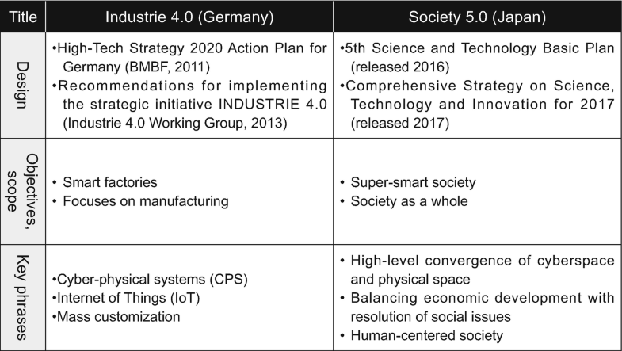
Fig. 1.6
Industrie 4.0 vs. Society 5.0. Source: Produced by authors
There are some differences, however. Industrie 4.0 advocates smart factories, while Society 5.0 calls for a supersmart society. In addition, although both visions advocate the deployment of cyber-physical systems, the scope of deployment differs; in Industrie 4.0, CPS is to be deployed in the manufacturing environment, while in Society 5.0, it is to be deployed across society as a whole.
The two visions also differ in terms of measuring outcomes. Industrie 4.0 aspires to create new value and minimize manufacturing costs. Such down-to-earth outcomes allow for relatively simple and clear-cut performance metrics. By contrast, Society 5.0 aspires to create a supersmart society. The metrics in this case are much more complex. According to the Comprehensive Strategy on Science, Technology and Innovation for 2017, success is to be measured by how far society can “balance economic advancement with the resolution of social problems by providing goods and services that granularly address manifold latent needs regardless of locale, age, sex, or language to ensure that all citizens can lead high-quality, lives full of comfort and vitality” (Cabinet Office 2017).
There is also considerable difference in the scope of the intended future effects of technological innovations. Industrie 4.0 calls for an industrial revolution centered on manufacturing, but says nothing about how such a revolution may impact the public. By contrast, as illustrated by its concept of a people-centric society, Society 5.0 focuses heavily on the public impact of technology and on the need to create a better society. Included within the scope of Society 5.0’s vision is a course of reform intended to engender an inclusive society that caters to diverse needs and preferences. This important differentiating aspect of Society 5.0 was mentioned in an address delivered by Prime Minister Shinzo Abe to Chancellor Angela Merkel during the CeBIT conference in Hannover. Upon hearing Abe’s statements about Society 5.0, Merkel expressed her strong support for the vision (Prime Minister’s Office of Japan 2017; JETRO 2017a, b).

The Common Issues for Both Industrie 4.0 and Society 5.0
Japan is sometimes said to be a problem-stricken first-world country. The problems that Japan faces are complexly interwoven such that an improvement in one area often comes at the cost of another. To give an example, curbing welfare spending might be good for the nation’s fiscal health, but it would lead to grave problems in medical and healthcare environments. Similarly, we all understand the need to cut carbon emissions, but if we must live frugal lives to minimize their carbon footprint, that would run counter to the goal of ensuring that “all citizens can lead high-quality lives full of comfort and vitality.”
Accordingly, to ensure that Society 5.0 can solve these dilemmas and create a people-centric society, it is necessary to clarify the target metrics of such a society as well as the roles that policy and technology should play in achieving them. Chapter 2 of this book goes into more detail on the metrics for different social issues, including those related to a carbon-free society and the health of the elderly.
Industrie 4.0, with its vision of smart factories, emphasized the manufacturing sector as the main physical space (real world); as for cyberspace, it envisaged a CPS-centered cyber architecture wherein information is integrated horizontally between different industries and vertically within manufacturing systems. On the other hand, Society 5.0, with its vision of a supersmart society, emphasizes society as the main physical space (real world); as for cyberspace, it must strive for a CPS-centered cyber architecture wherein information is integrated horizontally between different service sectors (e.g., energy, transport) and vertically within the systems that track each service user’s history and attributes (such as their medical information, consumption behavior, and educational history). It must also achieve solid information security to enable the use of information.
Both Society 5.0 and Industrie 4.0 reflect Japan and Germany’s responses to global initiatives, and both make a statement to the international community. Both visions seek the integration of information between different industries or sectors, and they both face the same challenges to such an end: the need to overcome the regulatory and technical bottlenecks that stand in the way of constructing the necessary cyber architecture, and the need to establish ISO-style international standards and international information security institutions, which are necessary for building such an architecture. Many commentators note that Western countries lead the way on this score, so Japan must press ahead with building an information integration architecture, while keeping an eye on global trends. Both Industrie 4.0 and Society 5.0 seek to build global cyber architecture that can serve as a safe environment for creative activities. A key factor that will determine their success in achieving this goal will be how well they work with Western countries, China, and the international community at large.
In the case of Society 5.0, one key challenge concerns how to optimally balance the needs of society with the needs of the individual. We cannot achieve progress until we solve this problem. The actors involved in policy and technology must coordinate with each other so that everyone understands how each policy proposal or technological development fits into and contributes toward Society 5.0. Otherwise, these actors will pursue their own particular technologies or policies in an uncoordinated fashion without understanding how they fit into the larger picture of Society 5.0.
In relation to this challenge, clarifies the main social issues that Japan faces and outlines a framework for addressing them—namely, Habitat Innovation. Whereas Germany’s Industrie 4.0 focused on industry, Society 5.0 envisages a future society. In other words, in addition to revolutionizing industry through IT integration, Society 5.0 seeks to revolutionize the public’s living spaces, or habits. Further Chap. 2 progress must be made in promoting applied smart city initiatives. Additionally, the policies necessary for optimizing society (so as to solve social issues) must be adeptly linked with the technology necessary to deliver high-quality social services (that enable the public to live happy, comfortable lives). With this in mind, we have presented tentative suggestions for balancing the interests of society with those of individuals.

ANSWER THE Multiple Choice Questions – Module 14 AND UPLOAD TO PORTAL
- Society 5.0 is best defined as a society that aims to balance …
a. industrial growth and automation
b. economic advancement and social problem solving
c. technology and manufacturing efficiency
d. globalization and localization
e. innovation and competition
- The main difference between an information society and Society 5.0 lies in the fact that Society 5.0 …
a. limits the use of digital technology
b. focuses only on cyberspace
c. integrates systems across society as a whole
d. avoids automation
e. prioritizes industry over people
- In Society 5.0, data collected from the real world are mainly processed using …
a. manual calculations
b. traditional statistics only
c. artificial intelligence systems
d. paper-based models
e. human intuition
- The basic schema of Society 5.0 involves data being …
a. ignored after collection
b. stored without analysis
c. gathered, analyzed, and applied back to the real world
d. collected only for documentation
e. used only in cyberspace
- Cyberspace in Society 5.0 refers to …
a. a physical industrial area
b. a virtual space for data exchange and analysis
c. a social networking platform
d. a manufacturing facility
e. a government office
- The merging of cyberspace and physical space means …
a. eliminating physical activities
b. replacing humans with machines
c. creating a smooth data flow between real and virtual worlds
d. focusing only on digital products
e. reducing the role of data
- A people-centric society emphasizes …
a. maximum profit
b. automation without limits
c. human happiness and comfort
d. industrial productivity only
e. technological dominance
- One challenge in creating a people-centric society is …
a. lack of machines
b. limited data storage
c. balancing individual and societal interests
d. insufficient internet access
e. slow technological growth
- Cyber-physical systems (CPS) are systems that …
a. operate without computers
b. connect cyberspace models with physical environments
c. work only in factories
d. replace human decision-making entirely
e. function independently of data
- IoT plays a crucial role in Society 5.0 by …
a. reducing the amount of data
b. preventing automation
c. collecting varied and voluminous real-world data
d. replacing AI
e. limiting data sharing
- AI is important in Society 5.0 because it can …
a. store data manually
b. analyze vast amounts of data efficiently
c. eliminate cyberspace
d. replace physical space
e. stop technological development
- A knowledge-intensive society is one in which value is created mainly from …
a. natural resources
b. physical labor
c. knowledge and information
d. capital investment only
e. mass production
- Data are defined as …
a. analyzed conclusions
b. general laws
c. raw facts and figures
d. expert opinions
e. policy decisions
- Information differs from data because information is …
a. meaningless
b. unprocessed
c. data that have been selected and analyzed
d. always numerical
e. unrelated to decision-making
- Knowledge enables people to …
a. collect raw data
b. store information
c. make informed decisions
d. avoid analysis
e. eliminate uncertainty
- In a data-driven society, data can drive the real world …
a. only through human decisions
b. only through automation
c. both indirectly and directly
d. without technology
e. without analysis
- Automated traffic control systems illustrate data driving society …
a. manually
b. indirectly through reports
c. directly through AI-based automation
d. without any data
e. through written instructions
- One risk of a highly data-driven society is that people may …
a. become more creative
b. lose their sense of agency
c. avoid technology
d. reject innovation
e. stop using data
- Industrie 4.0 mainly focuses on …
a. education systems
b. healthcare services
c. smart manufacturing and factories
d. social welfare
e. public administration
- Society 5.0 differs from Industrie 4.0 because it emphasizes …
a. factories
b. manufacturing efficiency
c. society-wide solutions
d. industrial automation only
e. cost reduction
- Smart factories are characterized by …
a. manual labor
b. isolated machines
c. IoT and AI-based automation
d. low productivity
e. absence of data
- The fourth industrial revolution is marked by …
a. steam power
b. electricity
c. electronics
d. data integration and IoT
e. handcraft production
- One goal of Society 5.0 is to ensure that citizens can …
a. live without technology
b. achieve maximum profit
c. lead high-quality lives with comfort and vitality
d. work only in industries
e. avoid automation
- Knowledge sharing through cyberspace allows …
a. isolation between cities
b. duplication of problems
c. application of successful solutions across regions
d. restriction of innovation
e. elimination of data
- Universities in Society 5.0 are expected to play a role in …
a. limiting information access
b. promoting information illiteracy
c. cultivating information literacy and innovation
d. reducing technology use
e. preventing data sharing

